

ATAR Physics Unit 1

**Topic Test 2 – Ionising Radiation and Nuclear Reactions**

**Name**: _______________________

**Date**: ________________________

**Weighting**: 8% of Semester 1 mark

**Instructions:**

Show all working for your calculations, and express answers using appropriate units and significant figures.

You may refer to the Data and Formulae booklet.

**Time Allowed**: 50 minutes

**TOTAL MARKS**

**/50**

Teacher Comments:

**SECTION 1: SHORT ANSWER (15 Marks)**

1. **(3 marks)**

Complete the following table:

|  |  |  |  |  |
| --- | --- | --- | --- | --- |
| **TYPE OF**  **RADIATION** | **NATURE** | **PENETRATING POWER** | **IONIZING POWER** | **SYMBOL** |
| ALPHA |  |  |  |  |
| BETA |  |  |  |  |
| GAMMA |  |  |  |  |

1. **(3 marks)**
2. What are the two major sources of background radiation?
3. In which of the following situations would you expect a person to be exposed to the highest level of radiation?
4. A pilot working for an international airline
5. Living in a house made of granite
6. An opal miner’s home underground at Coober Pedy
7. Explain your answer to Part (b) with reference to the probable sources of radiation.
8. **(3 marks)**
9. The radioisotope carbon-14 is formed by neutrons from primary cosmic rays striking nitrogen atoms in the upper atmosphere. $${}_{\text{7}}^{\text{14}}{\text{ N + }} {}_{\text{0}}^{\text{1}}{\text{ n → }}{}_{\text{6}}^{\text{14}}{\text{ C + X }}$$  
   What is the identity of the particle labelled “X”?

1. The radioactive carbon-14 then decays back to nitrogen-14. $${}_{\text{6}}^{\text{14}}{\text{ C → }} {}_{\text{7}}^{\text{14}}{\text{ N + Y }}$$  
   What is the identity of the particle labelled “Y”?

1. “The amount of carbon-14 in the atmosphere is constant.”   
   What can be deduced from this statement?
2. **(3 marks)**

Radon-222 is a gas which is given off in very small quantities by the ground. Radon-222 emits alpha particles and it has a half-life of approximately 4 days.

1. The emitted alpha particles cannot penetrate the skin. Why is radon so dangerous, then?
2. Why is radon more of a problem in houses during cold weather?
3. A sealed sample of radon-222 has an activity of 3.80 kBq. What will be its approximate activity in 20 days time?
4. **(3 marks)**

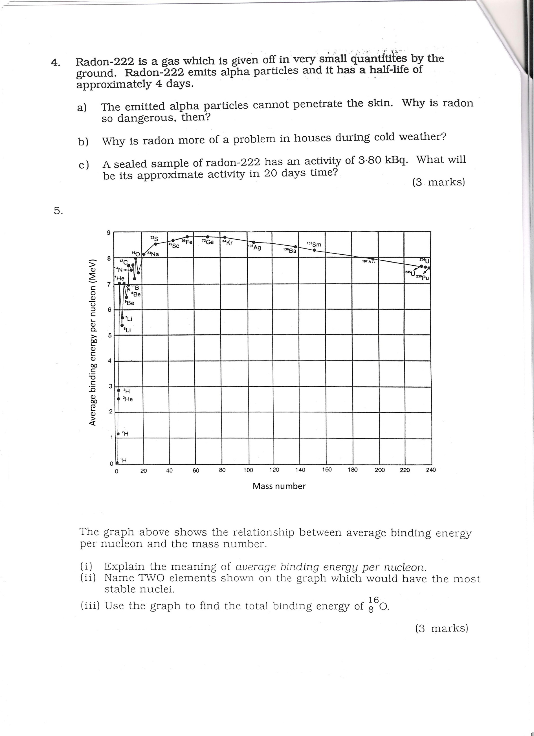

The graph above shows the relationship between average binding energy per nucleon and the mass number.

1. Explain the meaning of *binding energy per nucleon.*
2. Name TWO elements shown on the graph which would have the most stable nuclei.
3. Use the graph to find the total binding energy of ${}_{8}^{16}O$.

**SECTION 2: PROBLEM SOLVING (26 Marks)**

1. **(13 marks)**

Uranium-235 can fission according to the equation:

$${}_{\text{0}}^{\text{1}}{\text{n+ }{}_{\text{92}}^{\text{235}}{\text{U}}} → {}_{\text{56}}^{\text{141}}{\text{Ba + }{}_{\text{36}}^{\text{92}}{\text{Kr + 3}{}_{\text{0}}^{\text{1}}{\text{n + energy}}}}$$

1. Calculate the energy in joules that would be released from the complete fission of 1.00 kg of uranium atoms. The following data may be used. (7 marks)

mass of a neutron = 1.0087 u

atomic mass of U-235 = 235.0439 u

atomic mass of Ba-141 = 140.9139 u

atomic mass of Kr-92 = 91.8973 u

1 u = 1.66 x 10-27 kg

velocity of light c = 3.00 x 108 ms-1

1.00 kg of U-235 contains 2.56 x 1024 nuclei

1. The Trojan power station in Oregon produces 9.76 x 1013 J of electrical energy per day. In theory, how many kilograms of U-235 would be needed to produce this energy? (3 marks)
2. The Trojan power station, in fact, uses 2.78 kg of U-235 per day. Discuss the reasons for the difference in the mass of U-235 used. (3 marks)

1. **(13 marks)**

An industrial physicist accidentally swallows a radioisotope with an activity of 10.0 kBq. The material swallowed has a very long effective half-life. You can assume therefore that the activity will not change appreciably during the physicist’s lifetime. Each decay of the isotope releases 1.60 x 10-13 J of energy into the body. Assume that all the energy is absorbed by the physicist’s body and that the radioisotope is not eliminated from the body.

1. Determine the amount of energy absorbed in one year. (5 marks)

(1 year = 365 days)

1. If the physicist has a mass of 70.0 kg, determine the energy absorbed per kg in one year. (2 marks)

1. What is the absorbed radiation dose in grays per year?
2. Gy = 1 J kg-1) (2 marks)

Some types of absorbed radiation are potentially more damaging than others. For example, a particular absorbed dose of α radiation is much more damaging to the cells of the body than the **same dose** of β or γ radiation.

To take this into account the absorbed dose is multiplied by an extra weighting called the **Quality Factor (QF)**.

The following table shows the QF values for different kinds of radiation.

|  |  |
| --- | --- |
| **TYPE OF RADIATION** | **APPROX. QUALITY FACTOR** |
| γ rays | 1 |
| β particles | 1 |
| slow neutrons | 3 |
| fast neutrons | 10 |
| α particles | 10-20 |

Assume that the ingested radioisotope is an alpha emitter. (QF values = 15)

1. What is the equivalent absorbed radiation in sieverts per year? (2 marks)

1. Should the physicist be concerned about this yearly radiation exposure?

Explain. (2 marks)

**SECTION 3: COMPREHENSION (9 Marks)**

**Read the following statement about radioactive fall-out and answer the questions below.**

Radioactive fall-out following a nuclear accident may contain in excess of 100 radio-isotopes. Amongst these are iodine-131 (half-life 8 days) and strontium-90 (half-life 28 years). Both undergo beta decay. These isotopes are particularly dangerous to the health of mammals, including man, because they become involved in their ordinary life processes. Iodine in the diet is taken to the thyroid gland, where it is stored and involved in the making of thyroxine, a hormone concerned in the regulation of rate of growth and development in young mammals. Radioactive iodine-131 in the environment will rapidly concentrate in the thyroid gland and cause damage to tissue and possibly cancer. Once the thyroid gland has satisfied its need for iodine, the excess is excreted in the urine.

Strontium-90 is chemically similar to calcium, a vital constituent of bones, and is likely to be treated by the body as if it were calcium. An important source of calcium, especially for young mammals, is cow’s milk. If the cows have fed on pasture which has been contaminated by strontium-90 they will tend to concentrate the strontium in their milk, which, in turn, becomes concentrated in the bones of the young human.

1. What makes iodine-131 so serious a health threat after a nuclear explosion?

(provide at least two reasons) **(2 marks)**

1. Why are potassium iodide tablets given to people who have been exposed to radioactive fall-out? **(1 mark)**
2. Iodine-131 is often injected and the radiation used to obtain information about kidney function. Give two reasons that make iodine-131 suitable for this purpose. **(2 marks)**
3. Why is strontium-90 a greater long-term threat to human health than iodine-131?   
   (provide at least two reasons) **(2 marks)**
4. Given that strontium has chemical properties that are similar to those of calcium, where will the strontium-90 washed into streams and the ocean next be involved in a biological system? Does this pose a continuing threat to mankind? **(2 marks)**